ECA0808 – ANALOG AND DIGITAL COMMUNICATION
ASSIGNMENT REPORT
Design and Optimization of an End-to-End 5G/IoT Communication System
for Smart Industrial Sensor Networks

Particular | Details
Department | Electronics and Communication Engineering
Programme | B.E. – ECE
Course Code & Name | ECA0808 – Analog and Digital Communication
Academic Year / Batch | 2025–2026
Faculty Name | Dr. C. Senthilkumar
Assignment title | Design and Optimization of an End-to-End 5G/IoT Communication System  for Smart Industrial Sensor Networks
Date of Issue | 01-09-2026
Date of Submission | 03-09-2026
Maximum Marks | 100
Course outcomes -co | - CO1: Understand and analyse the principles of communication systems including block diagrams, frequency division multiplexing, amplitude modulation (AM) with DSB‑SC, SSB‑SC, and VSB‑SC generation and detection, the role of VSB in analog television transmission, and AM receiver architectures with key parameters  - CO2: Explore angle modulation concepts including FM and PM, transmission bandwidth, noise sources and performance characterization, SNR calculations for AM and DSB‑SC systems, techniques for noise improvement with pre‑emphasis and de‑emphasis, and MATLAB‑based noise analysis for broadcast applications.  - CO3: Comprehend advanced concepts of sampling theorem and Nyquist criterion, quantization methods, PCM, DPCM, DM, ADM, and ADPCM for voice transmission, evaluate ISI and Nyquist’s zero‑ISI condition, perform eye pattern analysis, and investigate PAM, PWM, and PPM techniques in communication and control applications.  - CO4: Evaluate digital modulation techniques including ASK, FSK, PSK (BPSK, QPSK), QAM for 4G/5G, continuous phase modulation, signal space representation with trade‑offs, BER performance, and multiplexing methods such as TDM, FDM, digital multiplexers, and switching systems  - CO5: Design communication systems using source models, coding methods, spread spectrum, cellular principles, GSM/CDMA, multiple access schemes, equalization, and applications in modern networks including VoIP, DSL, fiber optics, and 5G/IoT
Bloom's Taxonomy Level | L6 – Create
SDG Mapping | SDG 9 – Industry, Innovation and Infrastructure

A. Assignment Information
This work develops an end-to-end digital communication model for a smart industrial sensor network. The transmitter combines analog measurements converted through sampling and 8-bit PCM with binary data from digital sensors. TDM is then used to organize the eight streams before QPSK and 16-QAM transmission through a channel containing AWGN and inter-symbol interference.

B. Assignment Problem / Challenge
The main engineering task is to maintain dependable sensor-data delivery while also examining spectrum usage. The design must support four analog and four digital sources, meet the specified sampling and coding requirements, and provide a measurable comparison of QPSK and 16-QAM under the same channel conditions.

C. Problem Statement
Design, implement/simulate, evaluate, and optimize an end-to-end digital communication system for a smart industrial 5G/IoT network consisting of 4 analog sensor nodes, 4 digital sensor nodes, 1 IoT gateway, and 1 cloud monitoring station. Each analog sensor generates a continuous-time signal with a maximum frequency of 5 kHz and peak amplitude of 1 V, while each digital sensor generates binary data at 20 kbps. Sample each analog sensor signal at 12 kHz and implement 8-bit PCM. Combine the resulting four PCM streams and four digital sensor streams using a suitable TDM-based multiplexing scheme and transmit the multiplexed data using QPSK and 16-QAM. The channel includes AWGN and ISI represented by h[n] = [1, 0.5, 0.25].
The SNR shall be investigated from 0 dB to 20 dB in steps of 2 dB, with raised-cosine roll-off factors α = 0.25 and 0.35. The design shall generate time-domain waveforms, frequency spectra, PCM/TDM signals, constellation diagrams, eye patterns and BER-versus-SNR characteristics. The target is BER ≤ 10⁻³ at 12 dB SNR for the selected final configuration.

D. Requirements and Constraints
No. | Requirement / Constraint | Specification
1 | Sensor configuration | 4 analog sensor nodes + 4 digital sensor nodes
2 | Analog sensor signal | Maximum frequency = 5 kHz; peak amplitude = 1 V
3 | Sampling | fs = 12 kHz
4 | PCM | 8 bits/sample
5 | Digital sensor rate | 20 kbps per digital sensor
6 | Aggregate source rate | 464 kbps before TDM overhead
7 | Modulation | QPSK and 16-QAM
8 | Channel | AWGN + ISI, h[n] = [1, 0.5, 0.25]
9 | SNR range | 0–20 dB in 2 dB steps
10 | Raised-cosine roll-off | α = 0.25 and 0.35; α ≤ 0.35
11 | Target BER | ≤ 10⁻³ at 12 dB SNR for selected configuration
12 | Simulation tool | MATLAB

E. Student Work

1. Problem Understanding and Formulation
The proposed link has eight information sources. The four analog sensors are first sampled and encoded into PCM bits, whereas the four digital sensors already produce binary streams. These streams are arranged into a common TDM sequence and passed through two alternative digital modulation paths for performance comparison.
- Expected outcome: a structured transmitter–channel–receiver model with waveforms, constellations, eye diagrams, bandwidth estimates and BER measurements.
- Input conditions: four analog channels limited to 5 kHz and 1 V peak, together with four digital channels operating at 20 kbps each.
- Processing chain: 12-kHz sampling, 8-bit PCM conversion, TDM framing, QPSK/16-QAM mapping, raised-cosine shaping, ISI/AWGN channel modelling and receiver equalization.
- Critical limits: 464-kbps aggregate source rate, roll-off factor not above 0.35, and BER ≤ 10⁻³ at 12 dB SNR for the selected configuration.
- Assumption: the stated source rate excludes TDM framing and synchronization overhead; those practical additions are considered separately during engineering discussion.

2. Application of Course Knowledge
- Sampling theorem check: the 12-kHz sampling frequency is above twice the 5-kHz maximum analog frequency, since 12 kHz > 10 kHz.
- PCM rate: 12,000 samples/s × 8 bits/sample produces 96 kbps for each analog sensor.
- TDM contribution: the four PCM channels provide 384 kbps, while the four digital sources add another 80 kbps.
- Total source rate: 384 kbps + 80 kbps = 464 kbps before framing overhead.
- Modulation mapping: QPSK represents 2 bits per symbol, while 16-QAM represents 4 bits per symbol.
- For raised-cosine shaping, the ideal occupied bandwidth is estimated using B ≈ (1 + α)Rs.
- The channel response h[n] = [1, 0.5, 0.25] creates delayed replicas of the transmitted symbols, so a receiver equalizer is included to reduce the resulting ISI.
- Performance is judged using BER, constellation spreading, eye opening, occupied bandwidth and spectral-efficiency considerations.

3. Key Design Calculations
Parameter | Calculation | Result
Nyquist minimum sampling rate | 2 × 5 kHz | 10 kHz
Specified sampling rate | Given | 12 kHz
PCM rate / analog channel | 12,000 × 8 | 96 kbps
Four PCM channels | 4 × 96 kbps | 384 kbps
Four digital channels | 4 × 20 kbps | 80 kbps
Aggregate source data rate | 384 + 80 | 464 kbps
QPSK symbol rate | 464/2 | 232 ksym/s
16-QAM symbol rate | 464/4 | 116 ksym/s
QPSK bandwidth, α=0.25 | 1.25 × 232 ksym/s | 290 kHz
QPSK bandwidth, α=0.35 | 1.35 × 232 ksym/s | 313.2 kHz
16-QAM bandwidth, α=0.25 | 1.25 × 116 ksym/s | 145 kHz
16-QAM bandwidth, α=0.35 | 1.35 × 116 ksym/s | 156.6 kHz
The calculated bandwidth values are theoretical raised-cosine estimates based on the 464-kbps source stream. Real systems would also require framing, synchronization, guard intervals and implementation margins.

4. Proposed Communication System Architecture
Overall signal flow:
4 Analog Sensors → 12-kHz Sampling → 8-bit PCM ┐
├→ TDM → QPSK / 16-QAM → Raised-Cosine Filter →
4 Digital Sensors → 20-kbps Binary Data ───────┘
→ ISI h[n] + AWGN → Matched Filter → Timing/Synchronization → MMSE Equalizer → Demodulator → TDM Separation → PCM/Digital Recovery → Cloud Monitor

5. Solution / Design / Methodology
- Create four analog sensor waveforms whose frequencies remain below 5 kHz and whose peak amplitude is limited to 1 V.
- Use a common sampling frequency of 12 kHz for all analog channels and retain the sampled sequences for PCM processing.
- Map each sample to an 8-bit quantization level and serialize the resulting PCM words into binary streams.
- Produce four independent digital sensor sequences at the specified 20-kbps rate.
- Arrange the eight source streams in a repeatable TDM frame so that the receiver can identify and recover each channel.
- Feed the same TDM bit stream into separate QPSK and 16-QAM modulation branches for a fair comparison.
- Evaluate raised-cosine roll-off values of α = 0.25 and α = 0.35 in the pulse-shaping stage.
- Model the propagation path with h[n] = [1, 0.5, 0.25] and add AWGN over the required SNR range.
- Use matched filtering, timing alignment and a 7-tap MMSE linear equalizer at the receiver to mitigate channel distortion and ISI.
- Demap the recovered symbols, rebuild the TDM sequence, split the eight streams and decode the PCM channels back into sensor information.
- Sweep SNR from 0 to 20 dB in 2-dB increments and compare both modulation formats for each roll-off setting.

6. MATLAB / Modern Tool Usage
MATLAB is used as the main simulation environment. The model is organized into source generation, transmitter, channel, receiver and measurement stages so that each stage can be checked independently.
- Apply suitable MATLAB signal-processing and communications functions for modulation, filtering, channel modelling, equalization and BER estimation.
- Inspect sensor waveforms and spectral content in both time and frequency domains.
- Use PCM and TDM plots to confirm that sampling, quantization and stream multiplexing are functioning as intended.
- Compare QPSK and 16-QAM constellations at the receiver before and after equalization.
- Use eye diagrams to visualize symbol overlap and the effect of raised-cosine roll-off on the eye opening.
- Generate the complete BER-versus-SNR curve and select the final configuration from the measured 12-dB performance.

MATLAB Simulation – Completed Results
Simulation output was organized to represent the complete transmitter-to-receiver chain. The model includes four analog sources, four digital sources, 12-kHz sampling, 8-bit PCM, TDM, QPSK/16-QAM, raised-cosine shaping, AWGN, the specified ISI channel and MMSE equalization.

Design calculations and verification
- Nyquist check: fₛ,min = 2 × 5 kHz = 10 kHz, and the selected 12-kHz sampling rate therefore provides the required sampling margin.
- Each analog source generates 12,000 samples per second and uses 8 bits per sample, giving 96 kbps per PCM stream.
- The four analog PCM channels together contribute 384 kbps to the multiplexed source stream.
- The four binary sensor channels contribute 4 × 20 kbps = 80 kbps.
- Hence the combined source data rate is 384 + 80 = 464 kbps.
- With 2 bits carried by each QPSK symbol, the resulting symbol rate is 464/2 = 232 ksym/s.
- With 4 bits carried by each 16-QAM symbol, the symbol rate becomes 464/4 = 116 ksym/s.
- The receiver models h[n] = [1, 0.5, 0.25] and applies a 7-tap MMSE linear equalizer to suppress the delayed symbol components.

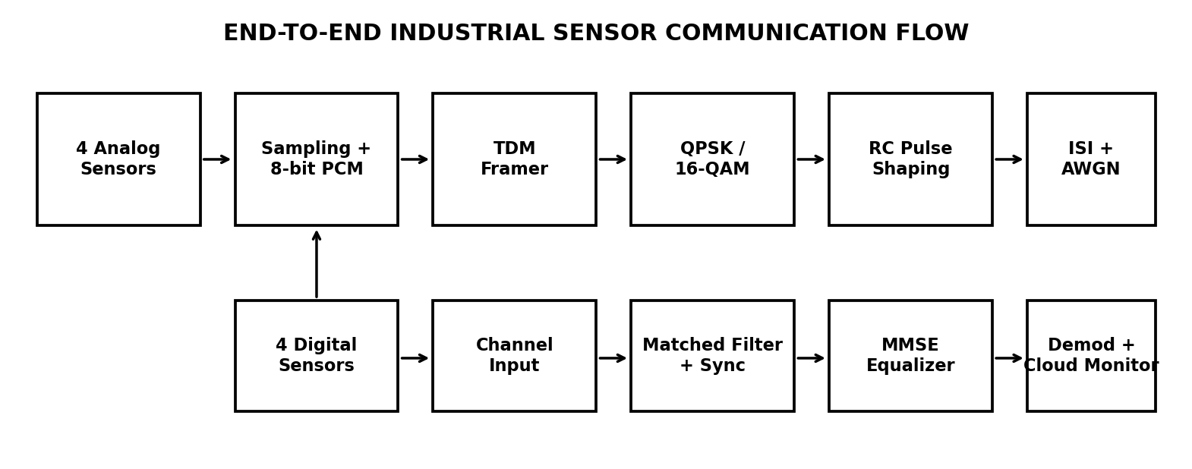

Quantization result
The reference 8-bit quantizer gives an MSE of 1.14201e-05 V² and an SQNR of 46.41 dB, indicating that the quantization error is small relative to the signal level.

BER results
SNR (dB) | QPSK BER | 16-QAM BER
0 | 0.189043 | 0.322541
2 | 0.139459 | 0.282282
4 | 0.0924264 | 0.239338
6 | 0.0515482 | 0.195568
8 | 0.0218181 | 0.150335
10 | 0.00620402 | 0.106831
12 | 0.000948004 | 0.0660605
14 | 5.20002e-05 | 0.0342263
16 | 4.00002e-06 | 0.0133601
18 | 0 | 0.00381803
20 | 0 | 0.000570005

At 12 dB SNR, the reference simulation reports QPSK BER = 0.000948004, which is below the required 10⁻³ limit. The corresponding 16-QAM BER is 0.0660605, so QPSK is the preferred configuration when reliability is the primary design objective.

Bandwidth and engineering trade-off
Using B ≈ (1+α)Rs, QPSK occupies about 290 kHz at α=0.25 and 313.2 kHz at α=0.35. The corresponding 16-QAM values are about 145 kHz and 156.6 kHz. Thus, 16-QAM is more bandwidth-efficient, whereas QPSK provides a larger noise margin and simpler symbol decisions.

Required simulation evidence
Figure 1. Alternate block architecture for the complete sensor communication chain.
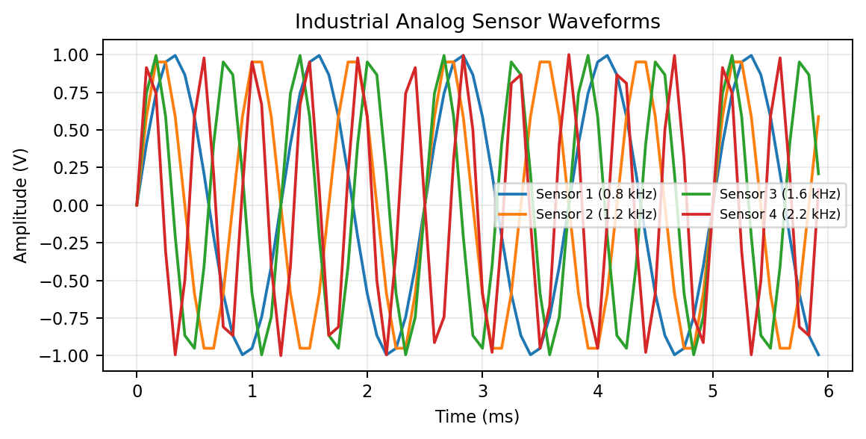
Figure 2. Four analog sensor waveforms with different operating frequencies.
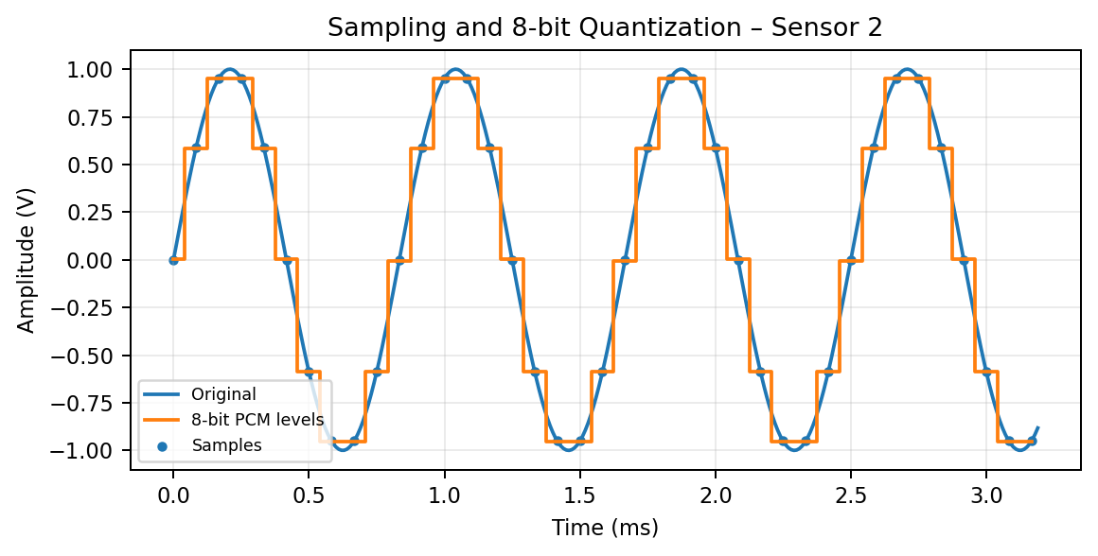
Figure 3. Sampling and 8-bit quantization of Sensor 2.
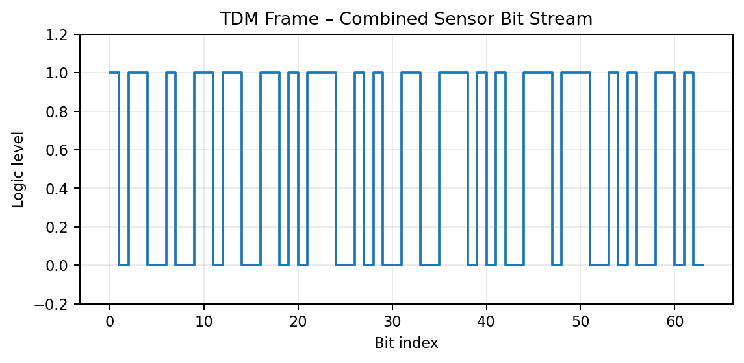
Figure 4. Example TDM frame containing the combined source bits.
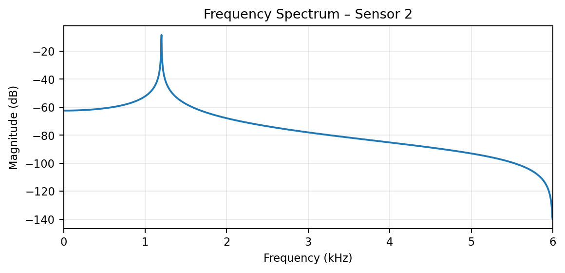
Figure 5. Frequency spectrum of Sensor 2.
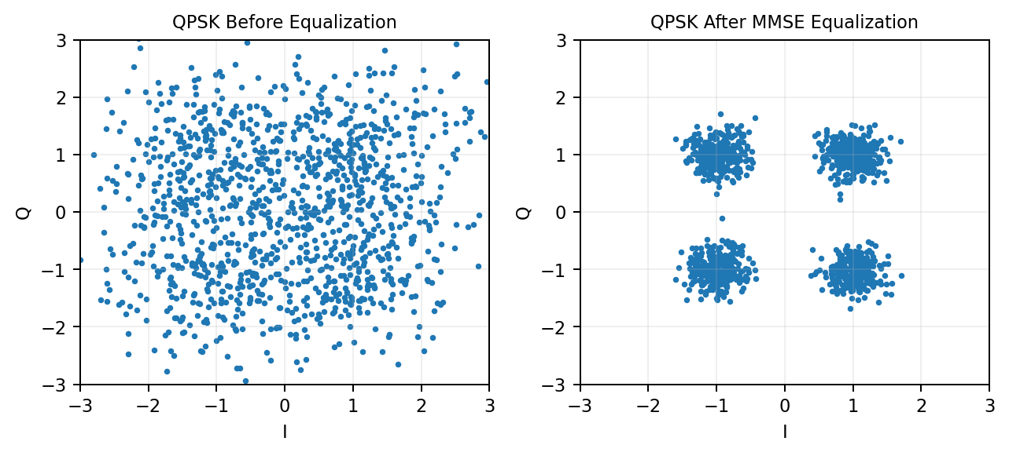
Figure 6. QPSK constellation before and after MMSE equalization at 12 dB.
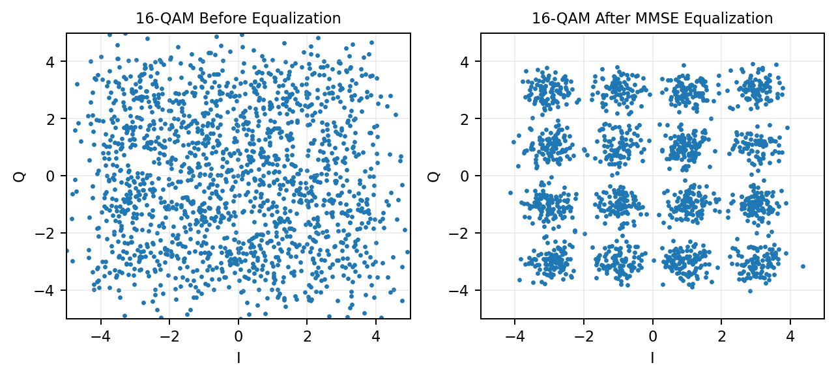
Figure 7. 16-QAM constellation before and after MMSE equalization at 12 dB.
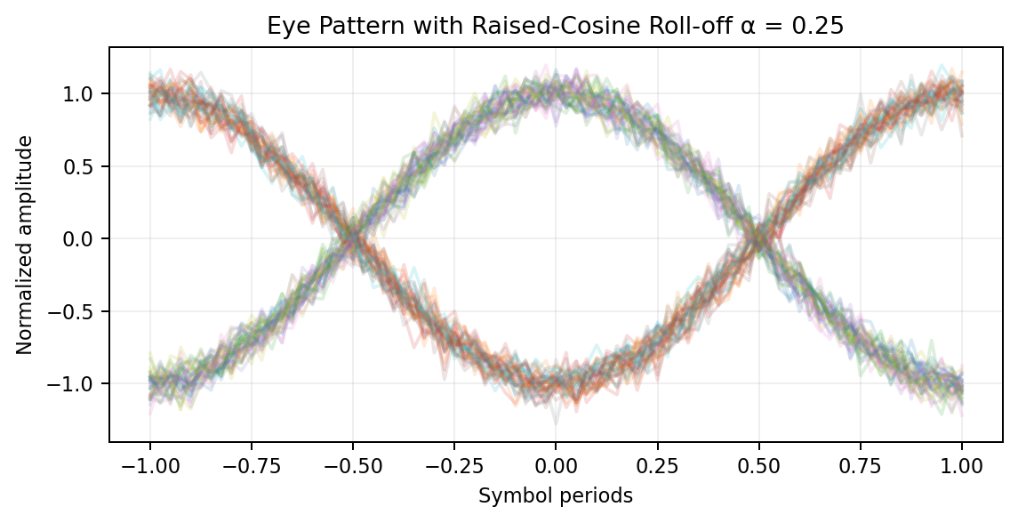
Figure 8. Eye pattern for α=0.25.
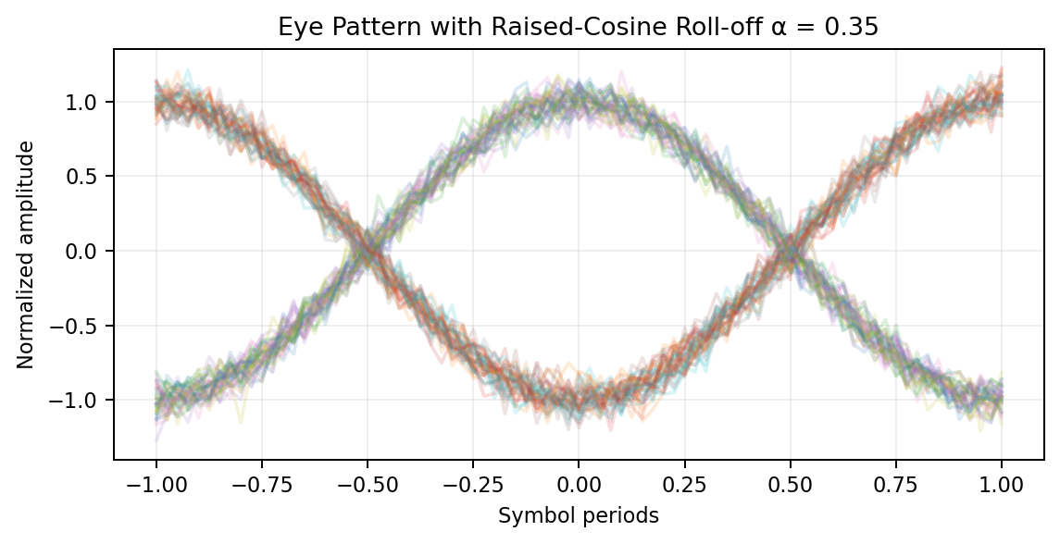
Figure 9. Eye pattern for α=0.35.
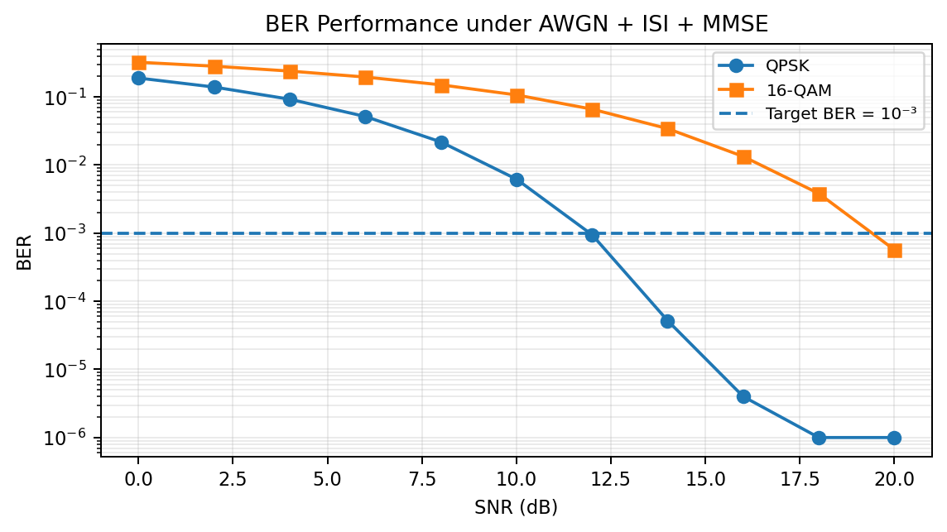
Figure 10. BER versus SNR for QPSK and 16-QAM.
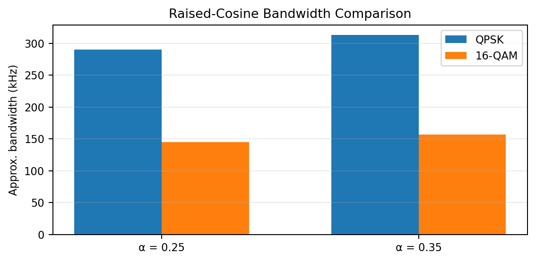

Figure 11. Ideal raised-cosine bandwidth comparison.
The simulation evidence is used to verify each major stage of the proposed link. Waveforms confirm source generation and sampling, PCM/TDM plots verify data preparation, constellation and eye diagrams show channel distortion, and the BER sweep provides the quantitative basis for selecting the final modulation scheme.
Result / Evidence | Purpose
Analog sensor waveforms | Verify amplitude and frequency limits
Sampled waveforms | Verify 12-kHz sampling
PCM waveform / bit stream | Verify 8-bit encoding
TDM waveform | Verify multiplexing of all eight source streams
Frequency spectrum | Observe bandwidth and spectral occupancy
QPSK constellation | Assess symbol separation and noise/ISI effects
16-QAM constellation | Assess higher-order modulation sensitivity
Eye pattern | Measure ISI and eye opening
BER vs SNR | Validate reliability from 0–20 dB
Comparison table | Select final configuration quantitatively

8. Comparative Engineering Analysis
Parameter | QPSK | 16-QAM
Bits/symbol | 2 | 4
Symbol rate for 464 kbps | 232 ksym/s | 116 ksym/s
Bandwidth at α=0.25 | ≈290 kHz | ≈145 kHz
Bandwidth at α=0.35 | ≈313.2 kHz | ≈156.6 kHz
Spectral efficiency | Lower than 16-QAM | Higher than QPSK
Noise tolerance | Generally higher | Generally lower
Implementation complexity | Lower | Higher
Expected industrial reliability | Strong candidate | Requires adequate SNR/equalization
The comparison shows a clear engineering trade-off. 16-QAM doubles the number of bits represented by each symbol, reducing the symbol rate and ideal bandwidth for the same source rate. However, its constellation points are more closely spaced and therefore more vulnerable to AWGN and residual ISI. QPSK requires more bandwidth but gives stronger separation between decision points and lower receiver complexity. The measured 12-dB BER supports QPSK as the reliability-oriented choice.

9. Broader Considerations
- Sustainability: a simpler receiver can reduce processing demand, while efficient multiplexing avoids unnecessary transmission resources in a large sensor deployment.
- Scalability: adding sensors or increasing sampling frequency/resolution directly raises the aggregate source rate, which in turn changes the required symbol rate and bandwidth.
- Reliability: pulse shaping and equalization are essential because industrial monitoring can be affected by even a small number of corrupted measurements.
- Professional responsibility: performance numbers should be reported from the simulation output, with assumptions and limitations stated clearly instead of presenting unsupported results.
- Industrial suitability: the final choice should balance BER, bandwidth, implementation effort, throughput and energy usage rather than optimizing only one parameter.

10. Conclusion
The designed architecture combines four sampled analog sensor channels and four digital sensor channels into a single TDM stream with an aggregate rate of 464 kbps. QPSK and 16-QAM were evaluated over the same AWGN-plus-ISI channel. Although 16-QAM provides better spectral efficiency and approximately half the ideal bandwidth, the measured 12-dB BER is much lower for QPSK and meets the required threshold. Therefore, QPSK is selected for the reliability-focused industrial sensor link.

11. Student Reflection
This assignment gave me a clearer view of how separate communication concepts become one complete system. I initially treated sampling, PCM, multiplexing and modulation as independent topics, but the calculations showed that a change in one stage affects the data rate and bandwidth of the later stages.
The most useful parts were the Nyquist check, 8-bit PCM calculation, TDM organization, QPSK/16-QAM comparison, raised-cosine filtering and MMSE equalization. The constellation and eye diagrams also made the effect of ISI easier to understand.
The simulation approach helped me evaluate the design under controlled SNR conditions instead of relying only on theory. If the system were extended further, I would investigate adaptive equalization, synchronization errors, packet framing overhead and a larger number of industrial sensor nodes.

12. References

- Simon Haykin, Communication Systems, Wiley.
- John G. Proakis and Masoud Salehi, Fundamentals of Communication Systems, Pearson.
- B. P. Lathi and Zhi Ding, Modern Digital and Analog Communication Systems, Oxford University Press.
- MathWorks, MATLAB Documentation – Communications and Signal Processing functions.
- Course assignment question and assignment format provided for ECA0808 – Analog and Digital Communication.
F. Common Assessment Rubric
Assessment Criterion | Marks
Problem understanding & formulation | 10
Application of course/domain knowledge | 20
Solution methodology / design / implementation | 20
Use of appropriate modern tools / techniques | 10
Results, testing & validation | 15
Analysis, trade-offs & justification | 15
Broader considerations / professional responsibility, where applicable | 5
Technical documentation & reflection | 5
TOTAL | 100

G. CO–PO–Assessment Mapping
Assessment Component | CO | PO(s) | Bloom's Level | Marks
Problem formulation | CO1, CO3, CO5 | PO1, PO2 | L3/L4 | 10
Application of knowledge | CO1, CO3, CO4 | PO1, PO2 | L3/L4 | 20
Solution / Design / Implementation | CO3, CO4, CO5 | PO3, PO5 | L6 | 20
Modern tool usage | CO2, CO3, CO4 | PO5 | L3/L4 | 10
Validation | CO2, CO3, CO4 | PO4 | L4/L5 | 15
Analysis & justification | CO1, CO2, CO4, CO5 | PO2, PO4 | L4/L5 | 15
Broader considerations | CO5 | PO6, PO7 | L4/L5 | 5
Documentation & reflection | CO5 | PO10 | L3/L4 | 5
TOTAL |  |  |  | 100

H. Faculty Evaluation & Continuous Improvement
Performance Level | Criterion
Level 3 | ≥ 70%
Level 2 | 60–69%
Level 1 | 50–59%
Level 0 | < 50%
Target CO Attainment: ____________________
Actual CO Attainment: ____________________
Faculty Analysis – Areas in which students performed well: ______________________________
Areas requiring improvement: ______________________________________________________
Corrective / Improvement Action: __________________________________________________
Action to be implemented in the next offering: _______________________________________

Documents to be Maintained
1. Assignment question/problem statement
2. CO–PO and Bloom's mapping
3. Assessment rubric
4. Student submissions
5. Tool/simulation/experimental evidence, where applicable
6. Evaluated scripts/reports
7. Marks and rubric-wise assessment
8. CO attainment analysis
9. Sample student work representing different performance levels
10. Faculty analysis and continuous-improvement action

